*California State University, Chico*

*Fall 2017*

ECON 495: Capstone

Senior Paper

**Effects of a Text Program on a Restaurant’s Transactions**

Jared Halterman

**Table of Contents**

Introduction………………………………….………………..2

Background…...………………………..……………...……..3

Methodology…………………………..………………..…….4 Variables……………………………..…………………..……4

Model………………………....……………………………….8

Regression & Testing……………….……………………….9

Analysis…………………………....…………………………10

Conclusion……………………...……………………………12

Tables & Figures…………………………………………….15

Bibliography………………………………………………….19

**Introduction:**

As businesses attempt to maximize their profits in the information era, they encounter many different options to paradigm shift away from their traditional operations. Many of these changes offered include promises of cost reduction, greater visibility, and an edge against their competitors. One upcoming shift is the switch from traditional to digital couponing. Digital couponing sounds very appealing to firms for there has been studies which conclude that digital coupons attract new buyers, have a higher return on investment (ROI), drive incremental volume, and allow for firms to to assemble profiles for light and heavy users (Heffernan). Complemented with a smaller cost than traditional, digital couponing appears to be the logical choice for firms to maximize their profits.

There is a specific type of digital couponing called text programs, which consists of willing participants who sign up to receive occasional coupons via text. In this paper, I will be examining the effects texts programs have on a restaurant’s business. Understanding the consequences text programs create is essential with a cost-benefit analysis that occurs when a business is contemplating switching their type of marketing. This paper will lend evidence to a text program’s effectiveness, specifically for a single restaurant. Additionally, this paper will not look at if it is profit maximizing to use digital, through cost minimization. A company might actually be better off using digital due to the lower costs, even if digital is less effective than traditional.

**Background:**

Acquiring a private company’s sale data is, not surprisingly, very difficult. Companies keep their sales data very private to deny competitors the ability to gain an edge in the market. In order to further my research, I required at least some sales data from a restaurant. Specifically, the data I required needed to be from a restaurant which is relatively busy and had a high number of members in their text program. Fortunately, a restaurant (Restaurant X), which fit all of my criteria, was willing to offer me their sensitive data and in return receive an undergraduate’s analysis of their marketing technique and a customer for life.

As I mentioned earlier, a necessary component for text programs to work is willing participants. There must be an audience in order to embrace the coupons, in fact, there must be a large audience in order for the text program to have a significant effect. This is the difficult part of establishing a text program. There needs to be a great incentive involved to encourage consumers to forfeit their phone number.

Restaurant X defeated this fundamental problem by offering a free appetizer when a consumer initially signs up. Restaurant X began offering this deal when they began pushing hard to recruit willing participants on August 1st, 2017. This incentive, along with mentioning the deal in every customer interaction, led to a high number of consumers signing up. For instance, in a three day period in September, Restaurant X was able to obtain 119 new members of the text program (Table 1).

The approach that Restaurant X uses their text program is as follows: two times a month they will text out a coupon to their text members, the period between the two coupon texts has a reminder text sent out, if not used, and then another reminder text after the second coupon text, if that one is not used. This approach, I believe, is a great medium between reminding customers to purchase Restaurant X’s goods, the purpose of coupons, and not annoying enough to cause text members to opt out.

**Methodology:**

In order to continue my research of the effect that text coupons have on a restaurant’s business, I will be creating a time series model and run a regression through STATA. I will need to gather variables that I believe will be useful in a model explaining Restaurant X’s business. After the model is completed, I will run tests to make sure that it is sound and then test the coefficient of the text program’s variable to see if it has a positive, negative, or no effect on a restaurant’s business.

**Variables:**

Figuring out which variables to include in my model was a difficult task, due to the lack of literature to review. Fortunately, through personal experience, asking the manager, and data mining, I was able to figure out the necessary variables. The most crucial variables required in my model are the dependent and the independent of interest. The dependent variable needed to capture the restaurant’s overall daily business and the independent variable needed to capture the use of the text program. The remaining independent variables would help explain what causes the restaurant’s daily business to increase or decrease.

From my own personal experience of working in a restaurant, I concluded that a restaurant can understand how busy they were on a single day by looking at the number of transactions. A relatively high number of transactions in single a day means that there was a high number of customers buying a product on that day. Inquiring the corporate office of Restaurant X about acquiring transactional data went smoothly. The corporate office provided me with daily transaction numbers from June 1, 2017 - October 22, 2017. June 1st was two months prior to the text program being pushed and October 22nd was the last day I could wait before beginning my project. The daily number of transactions variable will be denoted as *trans*t and act as my dependent variable representing Restaurant X’s business.

My independent variable of interest, the text program, was easy to find. On August 1, I personally signed up for the text program in order to see which days the text messages were sent out. I created a dummy variable, *text*, to represent those specific days. *Textt’s* coefficient will be the determining factor of whether text programs have an effect on Restaurant X’s business or not.

Working in a kitchen myself, restaurants experience different severity of business depending on the day of the week. Fridays are busier than Mondays and Tuesdays are slower than Saturdays, generally. In order to control for this, I created a dummy variable for each day of the week, excluding Wednesday. The omission of Wednesday is necessary, for I need to have a base when setting up dummy variables in order to have results when all of the other dummy variable days are equal to zero. I chose Wednesday as my base because according to the data, Wednesday’s daily average number of transactions is the closest to the overall daily average number of transactions. Having the average day as the base will allow the coefficient to make more sense when describing their effect. Again referring to my restaurant experience, I am expecting the following coefficients after running the regression: *mondayt* (-), *tuesdayt* (-). *thursdayt* (+), *fridayt* (+), *saturdayt* (+), *sundayt* (?). To understand this, for example, I believe Friday will have more transactions than Wednesday or I believe Monday will have less transactions than Wednesday. For Sunday, I am not confident enough to make a prediction.

Asking the manager of Restaurant X, I was able to obtain four more variables to include in my model. First of the four is football games. When football games are playing, specifically local favorites, (Raiders and the 49ers), there is an increase of customers coming into the store to watch the games on their TVs. Restaurant X has a NFL Season Pass, which gives them access to all games. To save on the price of buying the pass themselves, customers come into the store to watch and buy food and drinks. This creates the independent variable, *footballt* (+), a dummy variable which is active only on days that Raiders or the 49ers are playing, data which was easily found on ESPN’s website. The manager also stated that having football specifically on Sundays increases transactions when there normally wouldn’t be a transaction boost. To control for this, I created an interaction term called *footsunt* (+), which is simply *footballt* and *sundayt* multiplied together.

The other two variables are related to holidays. Restaurant X is open on all holidays during the time frame of the transactional data I received. Restaurant X’s manager described holidays as being busier than normal days because of many job sectors having the day off and school usually being cancelled, which allows families to go out and have lunch or dinner more than they normally would. I created a dummy labeled *holidayt (+),* which is active on holidays.

All holidays in my time-frame follow this rule besides the Fourth of July. July 4th is similar in the description of holidays I mentioned above, but a major tradition for Fourth of July is to barbeque with friends and family and view fireworks later in the night. There is still enough demand to have the store open, but there is a point in the night where the amount of customers decreases and there is not enough revenue to justify the operating costs. I can verify it because the store closes earlier than usual. Removing July 4th, from my *holidayt* variable, I create a separate dummy variable called *fourtht (-),* to explain the outlier on July 4th.

My final variable was discovered through data mining. After receiving the data from Restaurant X’s corporate office, I began creating random graphs of different scenarios I thought of and discovered an odd phenomenon. After creating a graph of average transactions on the numerical day of the month, (Figure 1), I noticed there seemed to be a significant decrease in the average number of transactions on the fifth day of the month. The only event that specifically happens on the fifth of a month, I could think of, was being the last day of rent being due for many renters, which would cause potential customers to be more price aware that day and eat-in or consume an inferior food in order to save money. Honestly, I do not buy that explanation and I believe that it is merely a coincidence within the time frame I acquired. Despite that, I will still include the effect of the fifth day of the month into my model as another dummy variable, *fiftht* (-).

**Model:**

Putting all the variables together into a simple time series model, I obtain the following model:

|  |
| --- |
| transt = β0 + β1textt+ β2mondayt+...β7sundayt + β8holidayt + β9footsunt +β10fiftht + β11fourth + εt  Includes Monday - Sunday, Wednesday excluded. |

β0 being my intercept, or the number of transactions I should expect if it was a Wednesday with no text sent out, not a holiday, no football game playing, and it wasn’t the fifth day of the month. The epsilon includes all the other explanations for number of transactions that my model could not capture. In order to get a conclusion for my research I will be setting up a null and alternative hypothesis:

|  |
| --- |
| H0 : β1 > 0. |
| Ha : H0 not true. |

If there is not sufficient evidence, at a 95% confidence level, to suggest Ha is true, I can accept that β1 is most likely positive (H0). If this is the case, I can then state with 95% confidence that sending texts to willing participants increases the number of transactions on that day.

**Regression and Testing:**

For my regression and testing, I will be using Stata (Small 13.0). After creating a time variable to set my data as a time series, I plugged in the variables and regressed. Figure 2 shows the results of my first regression. *Text*t, *thursday*t, *saturdayt*, *footballt*, and *fifth*t variable appear to be insignificant because of their >.05 p-values and because their 95% confidence interval includes zero. If this is the case I cannot determine my variable of interest to have an effect on Restaurant X’s transactions.

Before I delve too deep into these results, I created a scatter plot with the residuals in my model against the fitted values in my model (Figure 3). Looking at the position of the values, I had a suspicion heteroskedasticity was present within my model. To verify my suspicion, I ran a Breusch-Pagan test on my model. The resulting P-value (.0167), suggested evidence against the Breusch-Pagan hypothesis that my model had constant variance. So I rejected the given hypothesis and assumed my model was infected with heteroskedasticity. In order to correct for heteroskedasticity and get a more correct model, I reran my model, but with robust standard errors (Figure 4). Looking at the new results, *textt* and *fiftht* now become significant.

To test the multicollinearity between my variables, I ran a VIF test. The output, (Table 2), shows low correlation between my variables, which raises no concern. The highest correlated variables is my interaction variable and the involved variables with the interaction variable, which again raises no concern. After these tests, I come to the conclusion that my model is ready for analysis.

**Analysis:**

The first thing I notice in my new regression shocks me. My variable of interest coefficient is negative. This completely goes against the theory of marketing. Receiving a text offering a coupon and reminding you of the existence of a restaurant, should either have no effect or a positive effect on business. The fact that *textt’s* coefficient is negative leads me to believe there is something inherently wrong with my model. My model is suggesting that texts sent out to willing participants on an “average” Wednesday, disgusts potential customers so much, they refuse to undergo a transaction with Restaurant X.

To complete my hypothesis to achieve a conclusion with my research, I completed a one-sided t-test in Stata. The test resulted in a p-value of .019, which is strong evidence against my null of H0 : β1 > 0, which I then reject in favor of the alternative, (H0 is not true). From my model, I can conclude that texts do not have positive effect on Restaurant X’s transactions on the day the text was sent out.

Looking at the day dummy variable coefficients (Table 3), my expected coefficient signs were mostly correct. Monday and Tuesday were indeed significantly worse than Wednesdays on transactions. Thursday, which I expected a positive coefficient, actually ended up with a negative coefficient, but is not significant. A possibility I may have missed in my model, could be the specials Restaurant X runs on Wednesdays. Specials which are only available on Wednesdays could attract more customers and/or pull customers who would see Thursday indifferent from Wednesday. Sunday, which I had no idea what the sign of the coefficient would be, ended up being negative, significantly. Explanation possibly could be, Consumers spent all their “weekend budget” on Friday and Saturday and cannot spend anymore.

For the holiday variables, *holiday* and *fourth*, my expected coefficient signs were correct. I believe the theory I mentioned before explaining why I thought the signs would be why they were was correct.

My sports variables, *football* and *footsun*, had similar results as my holiday variables. My results indicate the days when there is a Raiders or 49ers game playing (*football*), results in a .69 increase in transactions. Although the coefficient is positive, it is not significant. If I look at the 95% confidence interval for football, there is a zero between the interval and the spread from zero is almost identical, we cannot confidently claim days when there is football there is a Raiders or 49ers game increases the transactions for Restaurant X. Football on Sunday (*footsun*) is a different story. The Sundays when there is a Raiders or 49ers game playing, there is an increase in transactions by 26.47. This variable is definitely significant. A potential reason for the difference between the two variables is, during the weekday when games are playing, potential consumers may be at work and unable to view the game at Restaurant X, thus increasing transactions.

The fifth day of the month variable’s (*fifth*) coefficient is positive and is statistically significant. However, I would not instantly claim that every fifth day of the month always means there is a decrease in the number of transactions by 15. I do believe it may be a coincidence with the limited data I requested. I believe given more data, the coefficient for the fifth day of the month would normalize to zero.

**Conclusion:**

Assuming my model is sound, I can conclude that the text program has a negative effect on the number of transactions and should immediately be put to an end. Also, I believe that despite the day of the week, if it is the fifth day of the month, Restaurant X should have less than average staff work that day in order to save on labor costs, due to the increase of transactions on the fifth day. However, I do not believe my model to be correct for a text program that has a negative effect is almost unheard of and if there was any effect *at all,* it would likely be positive. Likewise, the fifth day of month decrease does not make too much sense, because there is no good reason or theory as to why it would be negative on account of the numerical value of the day.

There is a few reasons why I believe my model failed. First, I don’t trust my model’s specification. There is too many dummy variables and I may be omitting important variables or trends that explain the number of transactions for Restaurant X. A lagged text variable may be important to include, to capture the effect the text message has on the days following after receiving the message. I ran a Ramsey Reset test and resulted with a p-value of 0.3, which indicates that I am not omitting variables, yet I believe I am. Second, my data time frame is too narrow. When I first started this research, I firmly believed the few months of data I inquired for would be enough to capture the coefficient of *textt*. The text program was just being pushed August 1st, so it wasn’t a good snapshot of the average willing participants there will be when the hard acquisition of new text club members resides.

A change in the dependent variable would, I think, give better results. Transactions is not the best way to measure Restaurant X’s business. Transactions can include one customer adding a dessert to their order last minute and then immediately after that transaction decide they want to order a drink. If the staff does not add it on to their original order, it would appear as three transactions, when it should have only been one. Transactions are also included in employee’s break food. Although it is a transaction, it should not be a measure of Restaurant X’s overall business, because the restaurant themselves are essentially increasing transactions by having more employees on the clock. A better dependent would daily revenue. In this case, I believe it would be more accurate of Restaurant X’s total business and would yield better results for my model.

The importance of a text program’s effect on a firm’s business is still very important. Deciding whether to shift from traditional to digital methods of marketing, to maximize profits, will take an in-depth and accurate analysis to calculate the pros and cons for each specific firm. Each firm is different and have different target demographics, which may require different techniques and incentives to be able to reach them digitally.

**Tables & Figures:**

Table 1:

|  |  |  |  |
| --- | --- | --- | --- |
| Restaurant | 9/2/2017 | 9/5/2017 | Growth |
| Restaurant X | 542 | 661 | 119 |

Table 2:

|  |  |
| --- | --- |
| Variable | VIF |
| footsun | 2.43 |
| sunday | 2.06 |
| football | 1.91 |
| saturday | 1.71 |
| tuesday | 1.68 |
| friday | 1.67 |
| thursday | 1.66 |
| fourth | 1.58 |
| monday | 1.57 |
| holiday | 1.56 |
| text | 1.08 |
| fifth | 1.05 |
| Mean VIF | 1.66 |

Table 3:

|  |  |  |  |
| --- | --- | --- | --- |
| Variable | Expected Coeff. | Actual Coeff. | Significant? |
| text | + | - | No |
| monday | - | - | Yes |
| tuesday | - | - | Yes |
| thursday | + | - | No |
| friday | + | + | Yes |
| saturday | + | + | No |
| sunday | ? | - | Yes |
| holiday | + | + | Yes |
| football | + | + | No |
| footsun | + | + | Yes |
| fifth | - | - | Yes |
| fourth | - | - | Yes |

Figure 1:

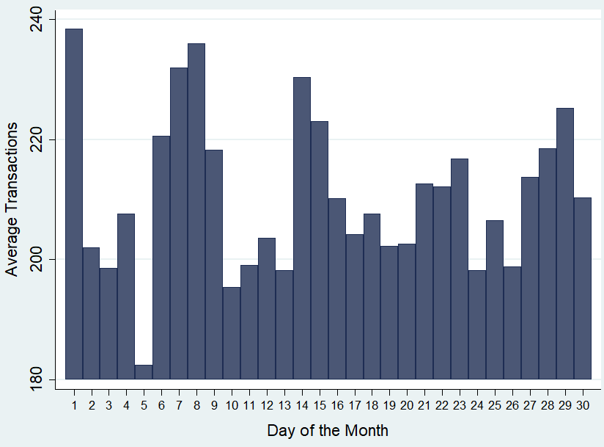

Figure 2: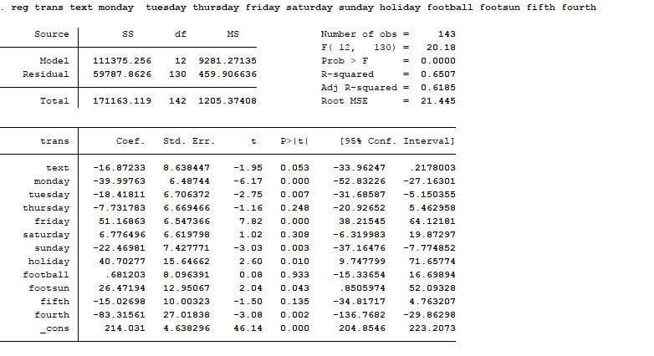

Figure 3:

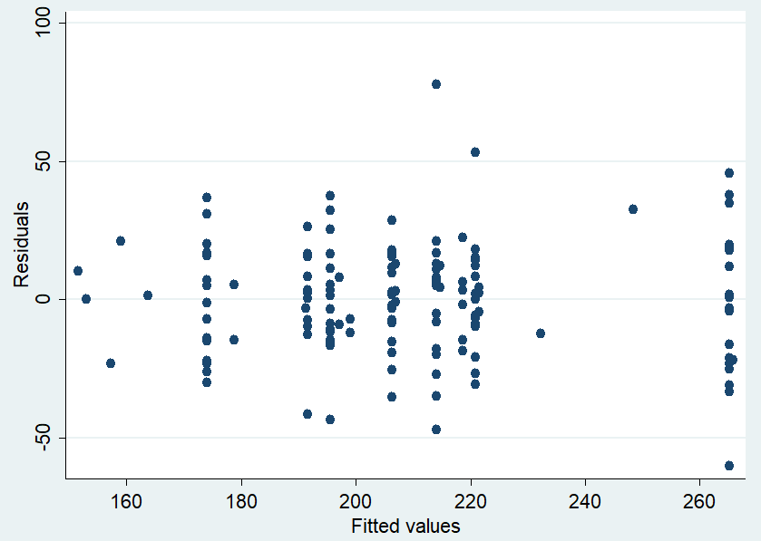

Figure 4:

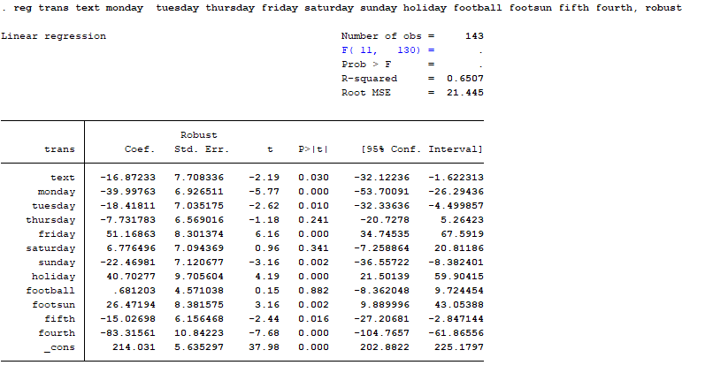

**Bibliography:**

Heffernan, Neal, Digital vs. Traditional Coupons. Knowledge Networks, 2011.

"The Worldwide Leader in Sports." ESPN. Accessed November 011, 2017. http://www.espn.com/.